Content-based Recommender System Using Cosine Similarity
Ritesh langde
Department of Computer Engineering
Sahyadri Valley College of Engineering and Technology
Pune, Maharashtra, India
Email: riteshlangde377@gmail.com

Laxman Khedkar
Department of Computer Engineering
Sahyadri Valley College of Engineering and Technology
Pune, Maharashtra, India
Email: khedkarlaxman823@gmail.com

Ashutosh Hase
Department of Computer Engineering
Sahyadri Valley College of Engineering and Technology
Pune, Maharashtra, India
Email: hase.ashutosh24@gmail.com

Abstract –
In the pursuit of personalized cinematic experiences, this paper introduces a Movie Recommender System leveraging Cosine Similarity within a machine learning framework. Developed using Python, the system processes a comprehensive movie dataset, extracting features such as genre, director, plot, title, and cast. By applying the cosine similarity algorithm, it assesses affinities between movies and user preferences. The system's performance is evaluated using precision, recall, and accuracy metrics, with the dataset divided into training and testing subsets to ensure robustness. Results demonstrate the system's effectiveness in providing accurate, individualized movie recommendations, enhancing user engagement in content discovery. Future work aims to integrate diverse machine learning algorithms and expand the system's capabilities.
Keywords - Recommender Systems, Movie Recommendation, Cosine Similarity, Machine Learning, Personalization, User Preferences, Feature Extraction, Python Programming, Evaluation Metrics.

Introduction
​In ​the digital era, the film industry's rapid expansion has inundated audiences with a vast array of movie choices, posing challenges for streaming services in delivering personalized recommendations. This paper introduces a Movie Recommender System that utilizes the cosine similarity metric to assess the resemblance between users' preferences and movie attributes—such as genre, director, actors, and content—represented as vectors in a multidimensional space. By calculating the cosine of the angle between these vectors, the system generates similarity scores that guide tailored movie suggestions. The study evaluates the algorithm's performance across diverse user profiles and examines its scalability with large datasets, aiming to enhance viewer experience by recommending films that align with past preferences and introducing users to new, potentially enjoyable movies.

Problem Statement –
​The rapid expansion of the film industry has led to an overwhelming array of movie choices, causing decision paralysis among viewers. Traditional recommendation systems often fail to capture the nuanced preferences of users, resulting in less accurate suggestions. Therefore, there is a need to develop a movie recommendation system that effectively analyzes extensive datasets, accurately discerns

individual user preferences, and delivers personalized movie suggestions to enhance the viewing experience.

Methodology –
Our approach begins with compiling a comprehensive movie dataset from reliable sources, followed by rigorous preprocessing to ensure data integrity and uniformity. We then extract key features—such as genre, director, actors, and plot—to numerically represent each film. Utilizing the cosine similarity algorithm, we calculate similarity scores between movies and user preferences, facilitating precise recommendations.

Scope of the Project –
This project aims to enhance the cinematic experience by providing personalized movie recommendations. It encompasses the entire recommendation process, from data collection to delivering tailored suggestions, contributing to advancements in machine learning and recommender systems.

RELATED WORK
Movie recommender systems have been widely researched, with various approaches aimed at improving accuracy and user satisfaction. This section reviews key contributions and identifies areas for further enhancement.

Collaborative Filtering Techniques -
Collaborative filtering, introduced by Goldberg et al. in the Tapestry system, enabled user-driven filtering. Resnick et al.'s GroupLens applied it to Usenet news, paving the way for scalable algorithms like Sarwar et al.'s item-based approach.

Content-Based Filtering Approaches -
Content-based filtering, pioneered by systems like Fab and NewsWeeder, was further refined by Pazzani and Billsus, emphasizing feature selection and user feedback. Mooney and Roy demonstrated its potential in book recommendations using text categorization.

Hybrid Systems-
To overcome the limitations of standalone methods, hybrid systems emerged. Burke outlined strategies for combining approaches, while Balabanović and Shoham’s Fab system showcased the effectiveness of integrating content-based and collaborative filtering.

Advancements in Machine Learning Algorithms –
Machine learning has significantly advanced recommender systems. Koren et al.'s matrix factorization techniques in the Netflix Prize competition demonstrated their scalability and accuracy in handling large datasets.

This Research’s Contribution –
This study leverages cosine similarity to enhance movie recommendations by analyzing user preferences and movie features. It aims to address data sparsity and improve personalization, ensuring users discover content aligned with their evolving tastes.

TECHNOLOGIES USED
- Jupyter Notebook – An interactive web tool for integrating live code, text, and visualizations, aiding dynamic data exploration.
- Python – A versatile programming language known for its readability and efficiency in data science and machine learning.
- NLTK – A Python library for natural language processing tasks like classification, tokenization, and parsing.
- Scikit-Learn – A machine learning library providing tools for data mining and analysis.
- TMDb API – A resource for accessing rich movie and TV show metadata to enhance recommendations.
- Streamlit – A framework for creating interactive web applications from Python scripts.
Identify applicable funding agency here. If none, delete this text box.

OVERVIEW OF MOVIE RECOMMENDER SYSTEM
Movie recommender systems enhance user experience by personalizing content based on individual preferences and viewing history. This section outlines key components, with a focus on cosine similarity for personalization.

Fundamental Components –
Item Profile – Describes movies based on attributes like genre, director, cast, and plot.
Recommendation Engine – The core algorithm that matches user preferences using collaborative filtering, content-based filtering, or hybrid methods.

Cosine Similarity: The Core Metric –
Cosine similarity is fundamental to the recommendation engine, measuring the similarity between user preferences and movie features. It computes the cosine of the angle between two non-zero vectors in a multi-dimensional space, aiding in personalized recommendations. The formula is:
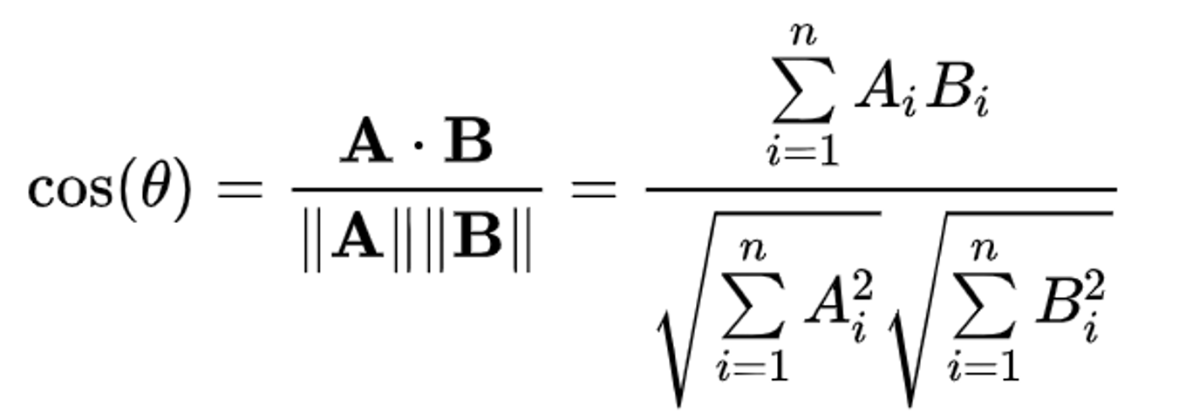
where A and B are feature vectors of movies or users.

Mechanics of Recommendation –
The process of generating recommendations involves several steps:
- Data Collection – Aggregating data to build item profiles.
- Preprocessing – Cleaning and structuring data for analysis.
- Feature Extraction – Identifying key attributes for similarity computation.
- Similarity Computation – Applying cosine similarity to measure relevance.
- Ranking & Suggestion – Ranking movies and recommending top matches.

DATA EXPLORATION
The effectiveness of a movie recommender system depends on high-quality, well-prepared data. This section details data collection and preprocessing.
A. Data Collection
- Sourcing – Accessing movie metadata from sources like TMDB and its API.
- Inclusion Criteria – Selecting movies based on release year, genre diversity, and industry representation.
- Acquisition – Ensuring data is current and relevant.
B. Data Preprocessing
- Cleaning – Removing incomplete or irrelevant entries.
- Normalization – Standardizing text, dates, and genres.
- Transformation – Converting categorical data into numerical format using techniques like one-hot encoding.
- Reduction – Selecting key features to enhance system efficiency.

FEATURE SELECTION & ENGINEERING
Effective feature selection and engineering optimize a movie recommender system by refining raw data into structured variables for accurate predictions.

Identifying Predictive Features –
Attribute Analysis: Identifying influential features such as genre, cast, and director.
Significance Testing: Evaluating attributes statistically to retain only the most impactful ones.
Feature Pruning: Removing redundant attributes to streamline the recommendation process.

Data Transformation for Algorithms –
To ensure compatibility with machine learning models, data undergoes:
Categorical Conversion: Encoding non-numeric features for processing.
Feature Synthesis: Combining attributes to uncover deeper user preference patterns.
Scaling: Normalizing numerical features to maintain balance in the algorithm.
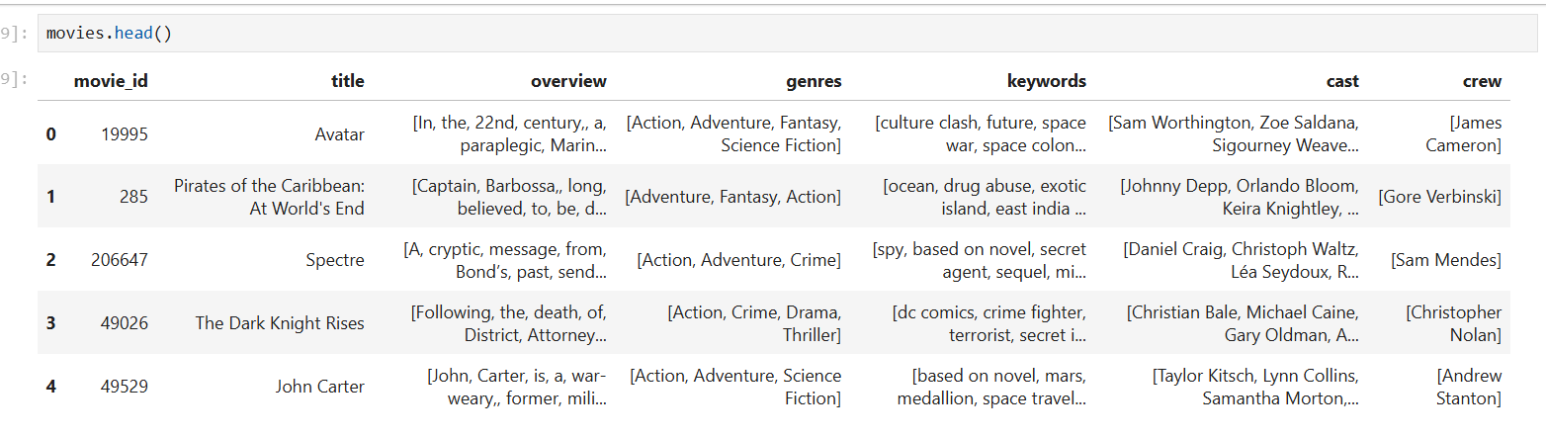
Fig 1. Feature Extraction & Transformation

MACHINE LEARNING
Machine learning plays a pivotal role in optimizing predictive modeling and personalizing recommendations.
Algorithm Selection: The system leverages algorithms designed to process sparse data matrices and generate accurate recommendations.
Predictive Analytics: Cosine similarity-based machine learning techniques analyze user preferences, enabling personalized movie suggestions.

PREDICTION MODEL
The system analyzes user data to predict preferences and recommend movies.
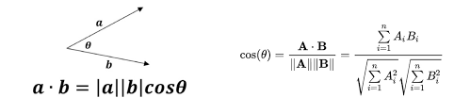

The system ranks movies based on similarity scores, recommending those that best align with the user’s preferences.
Cosine Similarity: Measures similarity between user preferences and movie attributes in a multi-dimensional space.
Algorithm Execution: Constructs vectors from features like genres and directorial styles, computing similarity scores for recommendations.
Tailored Recommendation: The system ranks movies based on similarity scores, recommending those that best align with the user’s preferences.

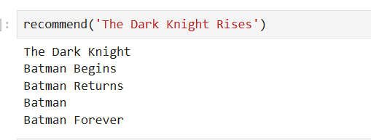

Recommendation System
The recommendation system integrates advanced algorithms and architecture to deliver personalized movie suggestionsbased on user preferences.
A. System Architecture Overview
The system employs cosine similarity to process data efficiently and tailor recommendations.
- Data Management: Utilizes the TMDB database to store movie details, including genre, cast, and narrative summaries.
- Processing Mechanics:
- Data Preparation: Standardizes and refines movie data.
- Feature Extraction: Identifies key characteristics for similarity assessments.
- Personalization Engine: Computes similarity scores to match movies with user preferences.
- User Interaction:
- Interactive Platform: Allows users to input preferences and receive recommendations.
- API Integration: Seamlessly connects with TMDB for enhanced accessibility.
- Machine Learning Workflow:
- Training Phase: Learns from movie features to predict preferences.
- Evaluation Phase: Assesses recommendation accuracy.
- Deployment Phase: Integrates the model into the system for real-time recommendations.
B. Algorithm Implementation
The cosine similarity algorithm is central to the recommender system, measuring the similarity between user preferences and movie attributes.
1. Cosine Similarity Computation: The similarity between the user profile and movie profile vectors is calculated using:
where A and B are feature vectors representing users and movies.
2. Recommendation Generation: Movies are ranked according to their similarity scores with the user’s profile. The system then suggests the top-ranked movies to the user.
3. Algorithm parameters, including feature weights, are fine-tuned to enhance recommendation accuracy and improve personalized suggestions.
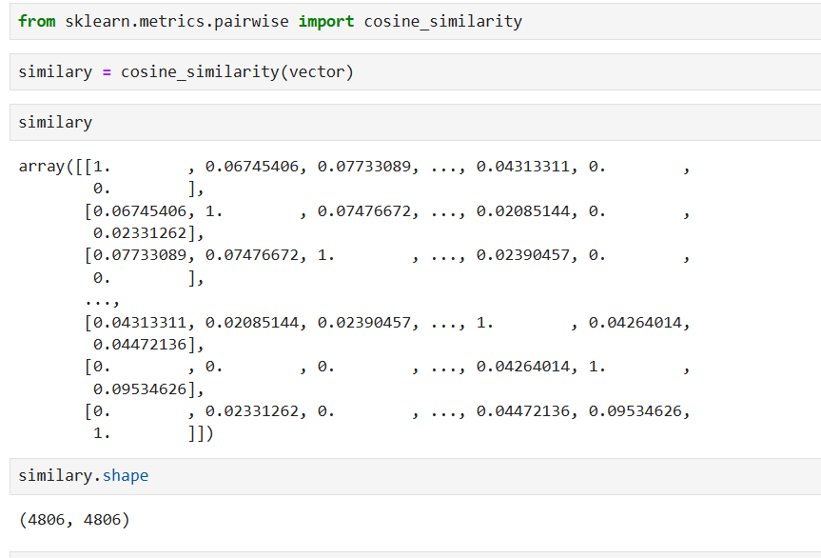C. API Integration
Integrating the TMDB API enhances the system by providing rich, up-to-date movie metadata and visuals for an engaging user experience.
- TMDB API Usage: Accesses detailed movie data, including titles, genres, and posters.
- Dynamic Poster Retrieval: Fetches movie posters in real-time for display in the recommendation interface.
- Seamless Integration: Queries the API using movie IDs and embeds the retrieved images into the UI.
- Improved User Engagement: Visual elements like posters enhance content recognition and user interaction.
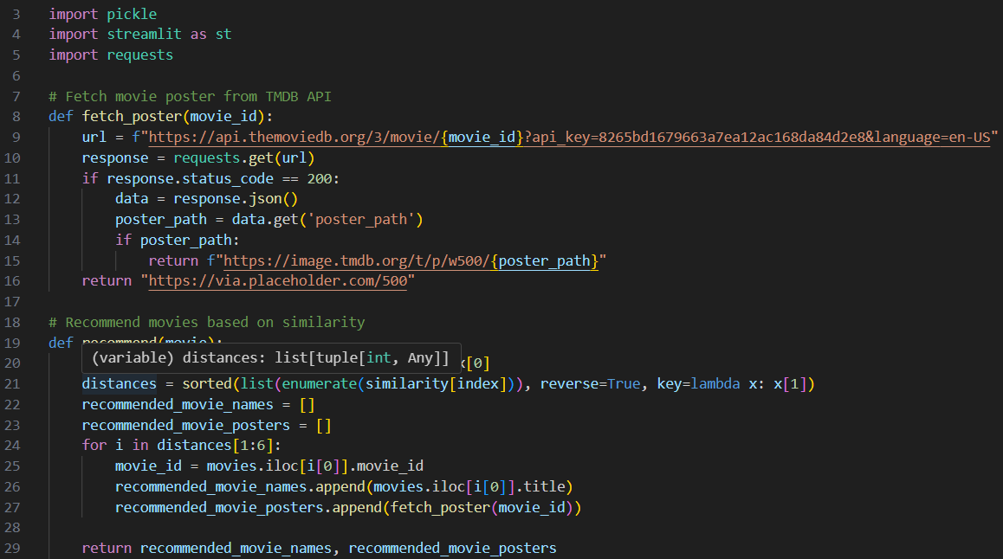
Fig 2. Fetching API Command

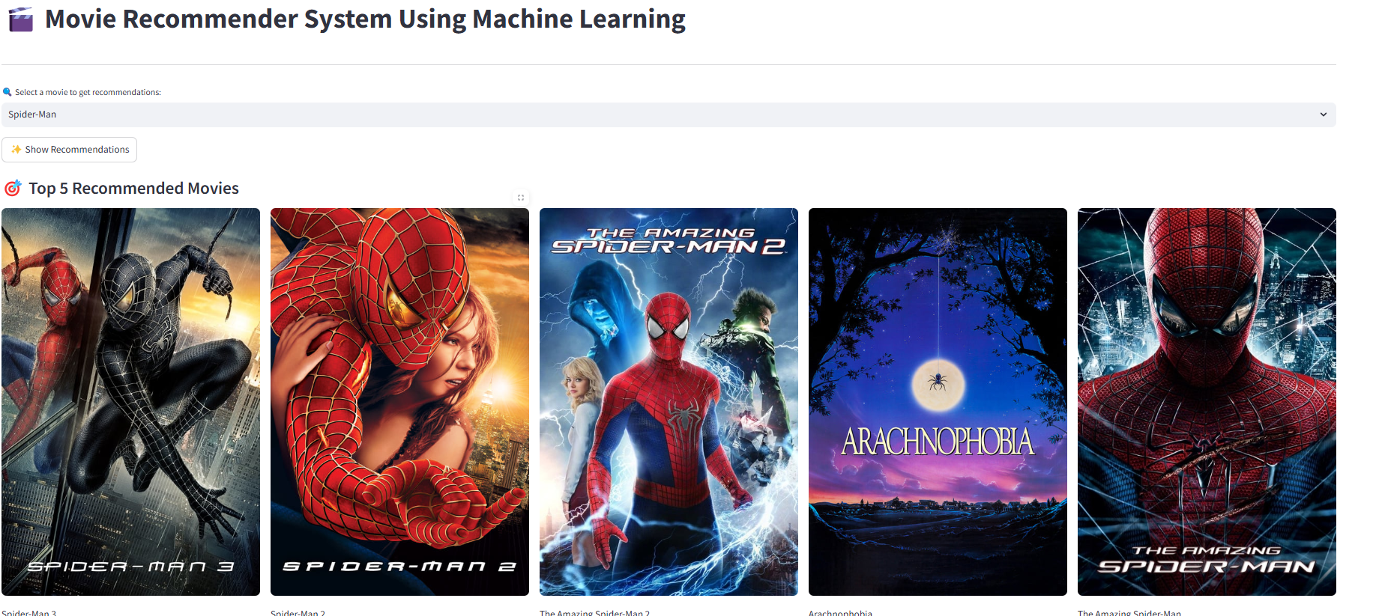Fig 3. Movies recommended on the basis of chosen movie

X. REFERENCES

[1] Resnick, P., Iacovou, N., Suchak, M., Bergstrom, P., & Riedl, J. (1994). GroupLens: An open architecture for collaborative filtering of netnews. Proceedings of the 1994 ACM Conference on Computer Supported Cooperative Work, 175-186, https://dl.acm.org/doi/10.1145/192844.192905 http://www.xxc.idv.tw/dokuwiki/study/resnick_p._iacovou_n._suchak_m._bergstrom_p._riedl_j._1994_._grouplens
[2] Sarwar, B., Karypis, G., Konstan, J., & Riedl, J. (2001). Item-based collaborative filtering recommendation algorithms. Proceedings of the 10th International Conference on World Wide Web, 285-295, https://dl.acm.org/doi/10.1007/s10844-017-0470-7
[3] Mooney, R. J., & Roy, L. (2000). Content-based book recommending using learning for text categorization. Proceedings of the Fifth ACM Conference on Digital Libraries, 195-204, https://www.cs.utexas.edu/~ml/publications/area/119/learning_for_recommender_systems
[4] Burke, R. (2002). Hybrid recommender systems: Survey and experiments. User Modeling and User-Adapted Interaction, 12(4), 331-370.
[5] Goldberg, D., Nichols, D., Oki, B. M., & Terry, D. (1992). Using collaborative filtering to weave an information tapestry. Communications of the ACM, 35(12), 61-70.
[6] Balabanović, M., & Shoham, Y. (1997). Fab: Content-based, collaborative recommendation. Communications of the ACM, 40(3), 66-72.
[7] Koren, Y., Bell, R., & Volinsky, C. (2009). Matrix factorization techniques for recommender systems. Computer, 42(8), 30-37.
[8] Linden, G., Smith, B., & York, J. (2003). Amazon.com recommendations: Item-to-item collaborative filtering. IEEE Internet Computing, 7(1), 76-80.
[9] Pazzani, M. J., & Billsus, D. (1997). Learning and revising user profiles: The identification of interesting websites. Machine Learning, 27(3), 313-331.

